# Cafe Management System

### A MINI PROJECT REPORT

#### Submitted by

#### Group/Team No: G14/T6

**Raghav Mehndiratta, 2310991104,**

**Rakshan Sharma, 2310991105,**

**Ranjan Minhas, 2310991106,**

#### in partial fulfillment for the award of the degree of

## BACHELEOR OF ENGINEERING

***in***

COMPUTER SCIENCE & ENGINEERING



**CHITKARA UNIVERSITY**

**CHANDIGARH-PATIALA NATIONAL HIGHWAY**

**RAJPURA (PATIALA) PUNJAB-140401 (INDIA)**

##### November 2023

###### TABLE OF CONTENTS

|  |  |  |
| --- | --- | --- |
| **Sr.no** | **Section** | **Page no** |
| **1** | Introduction | 3 |
| **2** | Problem Statement | 4 |
| **3** | Technical Details | 5 |
| **4** | Key Features | 6 |
| **5** | Project Highlights | 7 |
| **6** | Conclusion | 8 |
| **7** | References/ links used | 9 |

**INTRODUCTION**

**……………………………………………………………………………………………………………**

A Cafe management system is a type of point-of-sale (POS) software specifically designed for cafes, restaurants, bars, food trucks and others in the foodservice industry.

…………………………………………………………………………………Cafe Management System is based on a concept to maintain orders and management of a particular items. This project is developed in HTML and CSS. The role of the User is to maintain information including operations like modifying, deleting, updating the items records and customer order records in the system.

Cafe Management System is a windows form application developed in HTML and CSS programming language to carry out and manage basic cafe operations efficiently. This win application is perfect for a cafe or small coffee shop owners where they are in need of an application to run and simply ease out their day-to-day managerial task.

**PROBLEM STATEMENT**

**…………………………………………………………………………………………………..**

Managing a Cafe manually is not an easy task. It requires man-power and time. So as to overcome this problem, making a cafe management site is an efficient step as it not only decrease the work load but also helps in promoting the website through social media platforms.

**Some major Problems:**

• Manual billing may result in errors, and handling payments can be time-consuming.

• Managing inventory manually can be time-consuming and error prone.

• Incorrect orders and misunderstandings can lead to customer dissatisfaction.

• Updating menus and prices manually can lead to inconsistencies and delays.

• Maintaining data security and preventing fraud is crucial in handling customer information and transactions.

• Lack of insights into cafe performance can hinder strategic decision-making.

**TECHNICAL DETAILS**

**………………………………………………………………………….……………………….**

**Languages used:**

1. **HTML** – div , nav , p , form , link , span and many more tags ….
2. **CSS –** Id selectors , class selectors , tag selectors , Keyframes …
3. **JAVASCRIPT –** addEventListeners , GetElementById ….

**Code Editor Used:**

Visual Studio Code

**Brower’s Used:**

1. Chrome
2. Firefox
3. Microsoft Edge

**System details:**

Processor : AMD Ryzen 5 3450U with Radeon Vega Mobile Gfx

Installed Ram : 8 GB

**KEY FEATURES**

**………………………………………………..……………………………………………….**

**(1) Point-of-sale system**

**(2) Payment processing**

**(3) Cafe inventory management**

**(4) Reservation or table management solution**

**(5) Online or e-commerce system**

**(6) Online Ordering System**

**PROJECT HIGHLIGHTS**

(1) New Launches

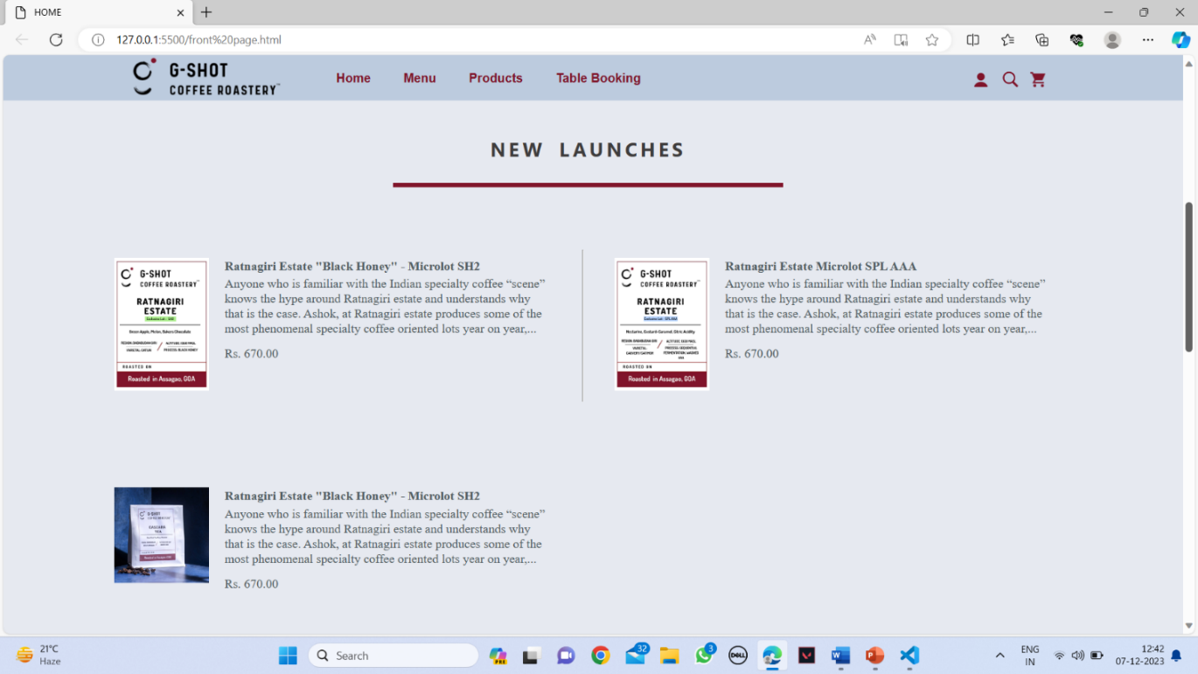

(2) Feedback form

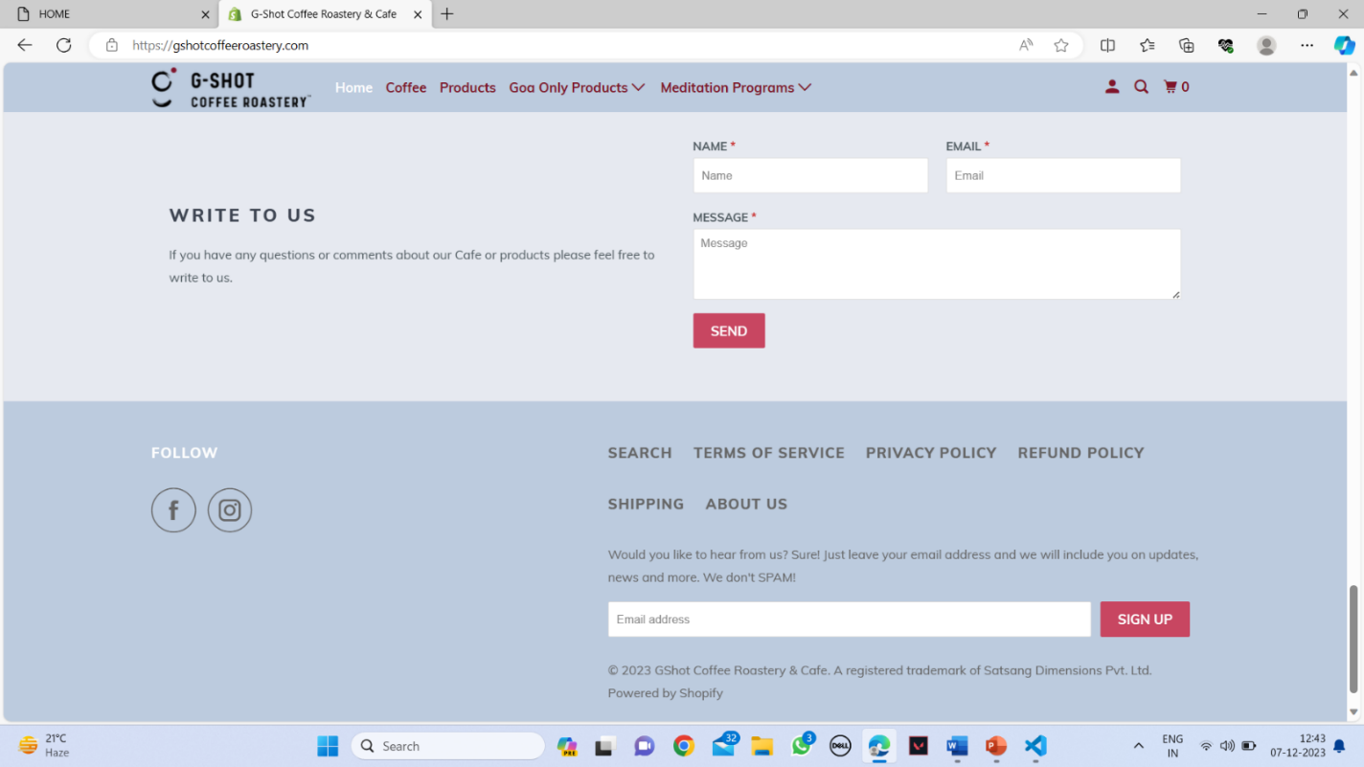

(3) Food Ordering Page

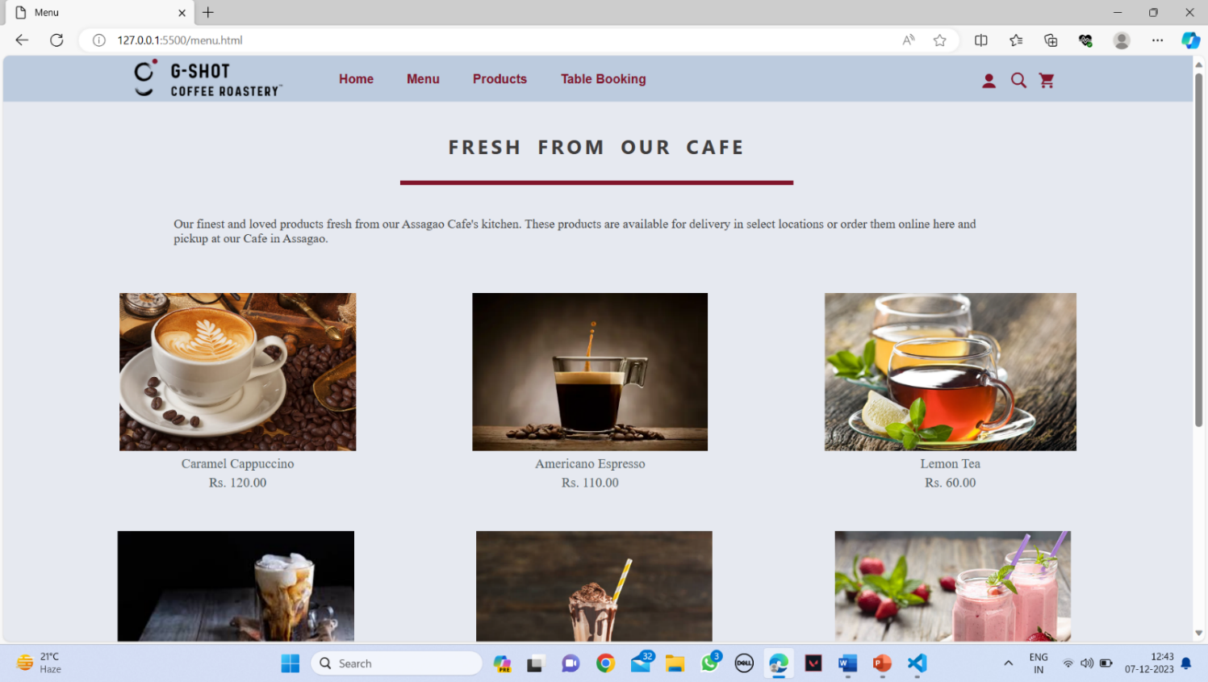

(4) Products Buying Page

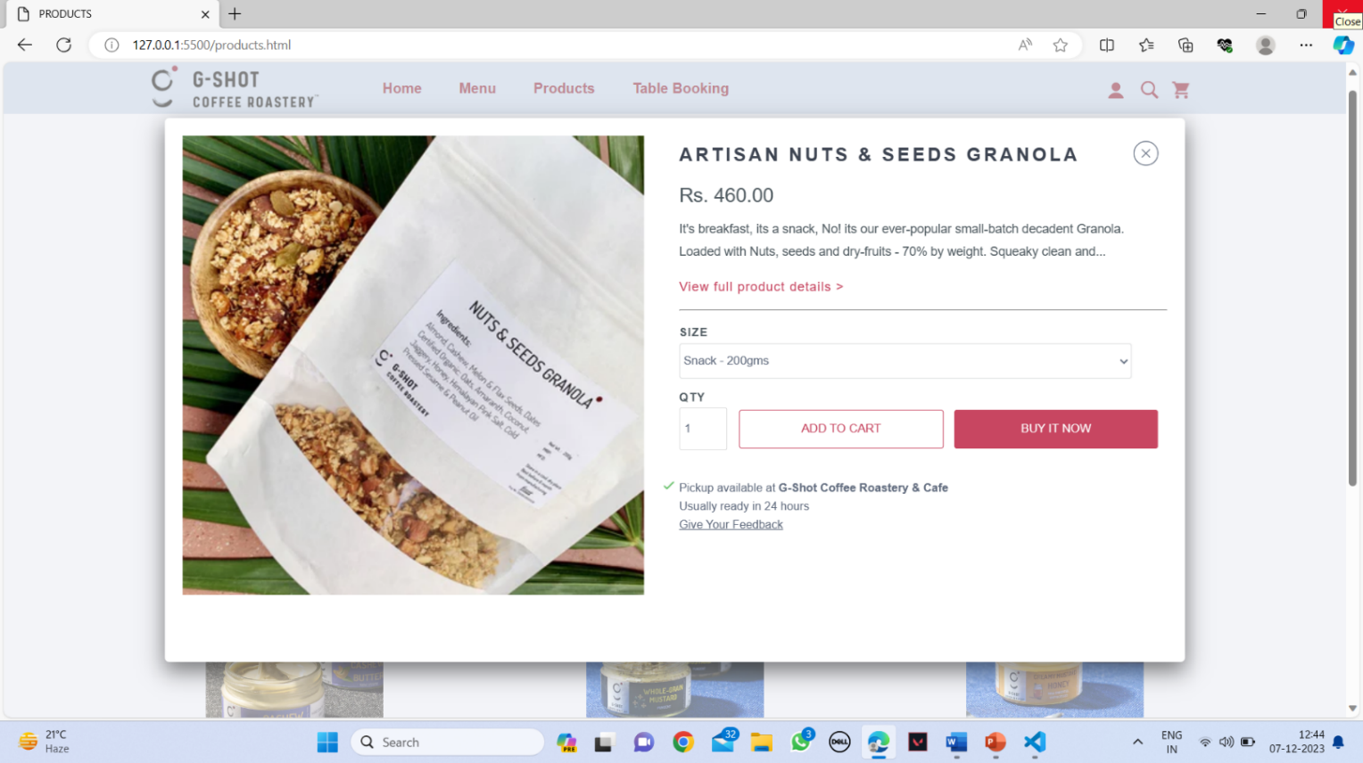

(5) Table Booking Page

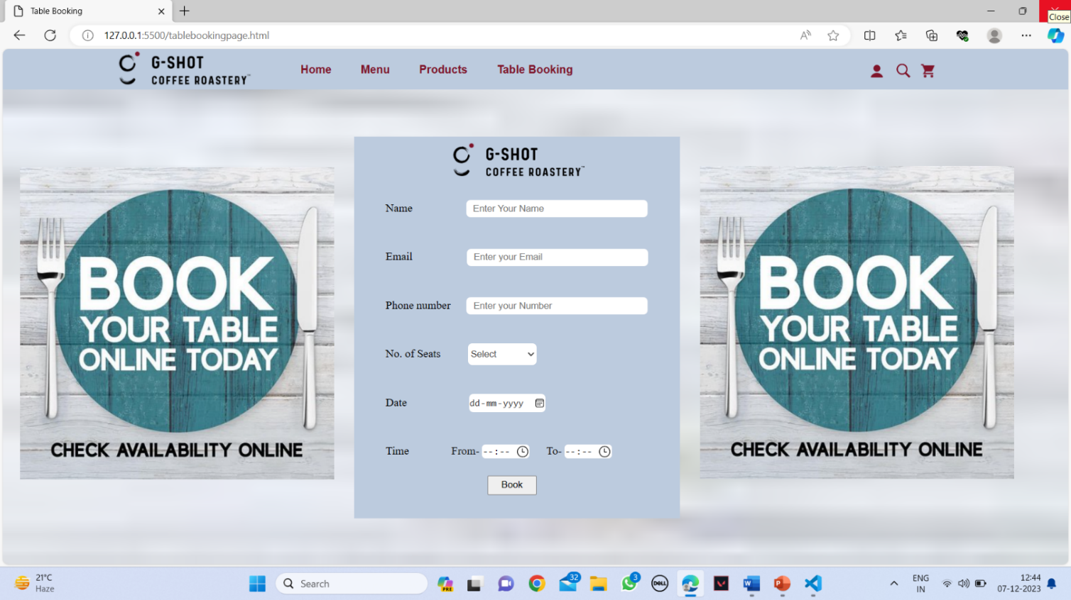

(6) Login Form

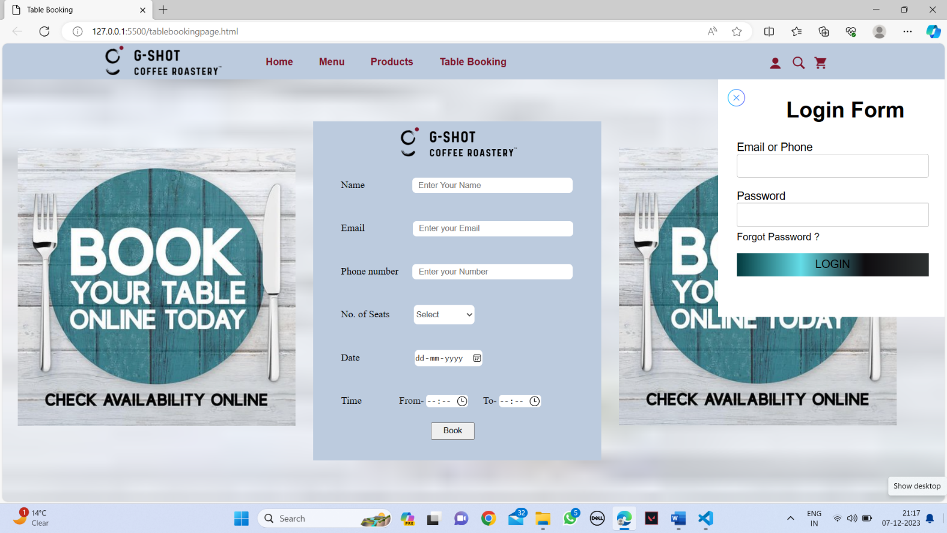

**CONCLUSION**

**…………………………………….………………………………………………………….**

Everything is upgrading with time very quickly as technology is evolving in this modern era. Like every other business restaurants should also consider using modern technologies to stay ahead.

The restaurant management system is very advanced software with seamless features and countless advantages. The advantages of restaurant management system include better customer service, employee satisfaction, cost reduction, more revenue and so much more.

**Some major advantages of using a Café Management System are:**

1. Better Customer Service
2. Keeping Track of Sales
3. Improved Reporting
4. Advance Security
5. Fewer Errors
6. More Productivity
7. Effective use of Time
8. Track Your Inventory
9. Reduce Cost

**REFERENCE/LINKS USED**

**…………………………………………………………………………………………………..**

[1] GOOGLE ICONS & CANVA STUDIO.

[2] <https://gshotcoffeeroastery.com>

[3] <https://getbootstrap.com>